**Assignment Day 5 Answer:**

**Question :** Make a word document and in that you make an AIDA marketing strategy for any product/service/brand of your choice with the below criteria: -

1.Mention the platform you will use (FB,IG,Google ads)

2.Demographics

3.Interests:(shopping,bikes,buying hoodies)

4.Content :text,Display ads,Video ads

**Answer :**

Having understood the stages, let us understand it better through an AIDA model for Netflix in India. It is a big task for Netflix to appeal to and convert Indian users who are accustomed to free content. Here’s what Netflix do to attract them –

**STAGE 1: Creating Awareness**

Netflix uses some common advertising mediums to inform the users about the offering. The mediums are –

* Print advertisements
* Youtube Advertisements
* Display Advertisements (Adwords)
* Partnerships with service providers like Airtel

It advertises about some really famous shows like Narcos and some Indian Netflix Originals like Sacred Games which are exclusive on Netflix.



### STAGE 2: Generating Interest

Once the users are aware and visit the Netflix’s landing pages, they are offered a **one-month free trial to explore experience all the shows and features on Netflix.**

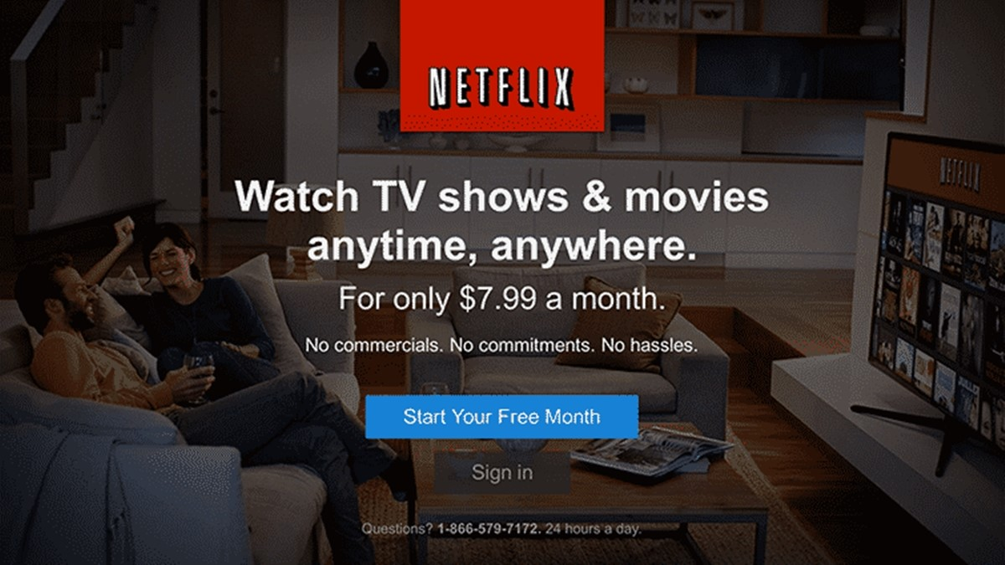

### STAGE 3: Securing Desire

As the viewers experience some features, they get used to the seamless viewing experience. At this point,  the following additional features create the desire to purchase the subscription plans –

* Netflix Exclusive movies, shows, and documentaries.
* High-resolution videos
* Support for every device (watch anywhere you go)
* Multiple TV series and movies from Hollywood, Bollywood, and other regional industries.
* Multiple profiles under one account
* Download and watch offline option
* No ads while streaming videos
* Personalized recommendations of TV shows and movies, based on viewing patterns
* Multi-screen viewing
* Continue watching a video from where you left
* Support for low-speed internet devices, etc.

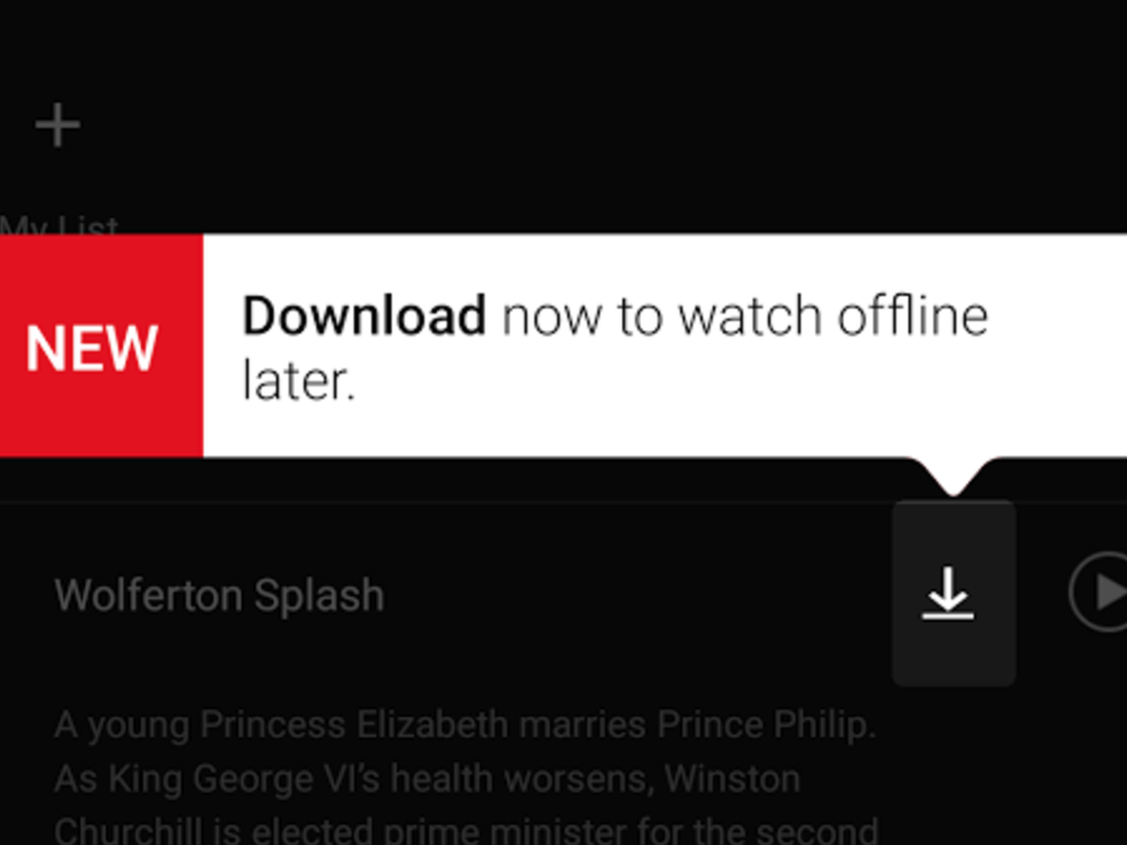

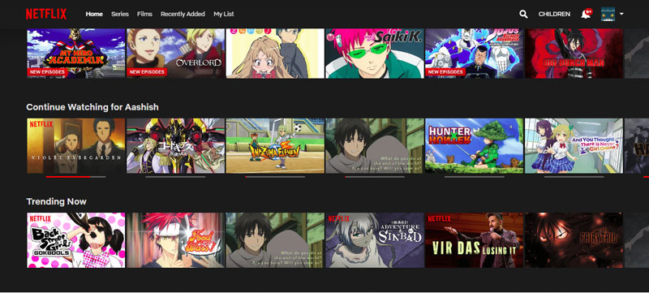

### STAGE 4: Enabling Action

Once the user is hooked to the offering, Netflix converts him into a real customer who pays. This is done by offering a variety of subscription plans and an option to stop the subscription any time.

